**PREREQUISITES**

**ANACONDA NAVIGATOR**

Anaconda Navigator is installed.

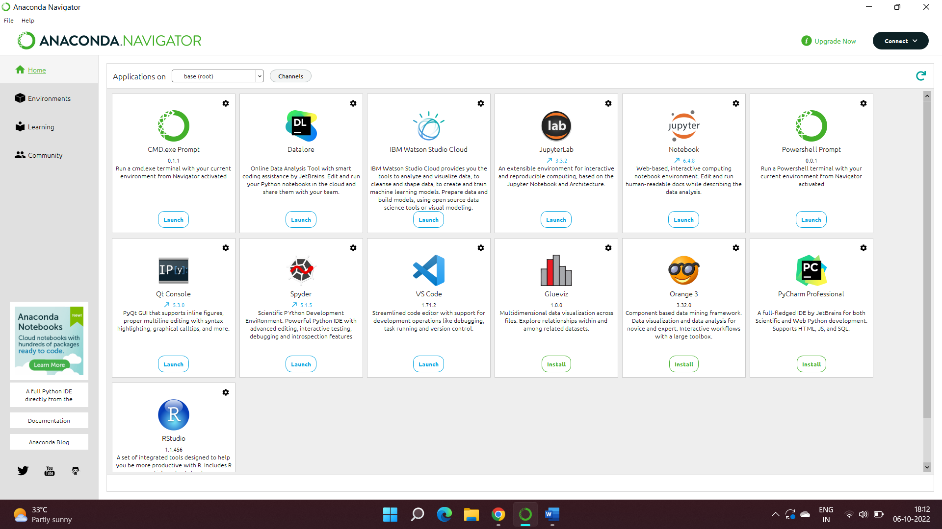

**PACKAGES INSTALLED**

numpy, pandas, matplotlib

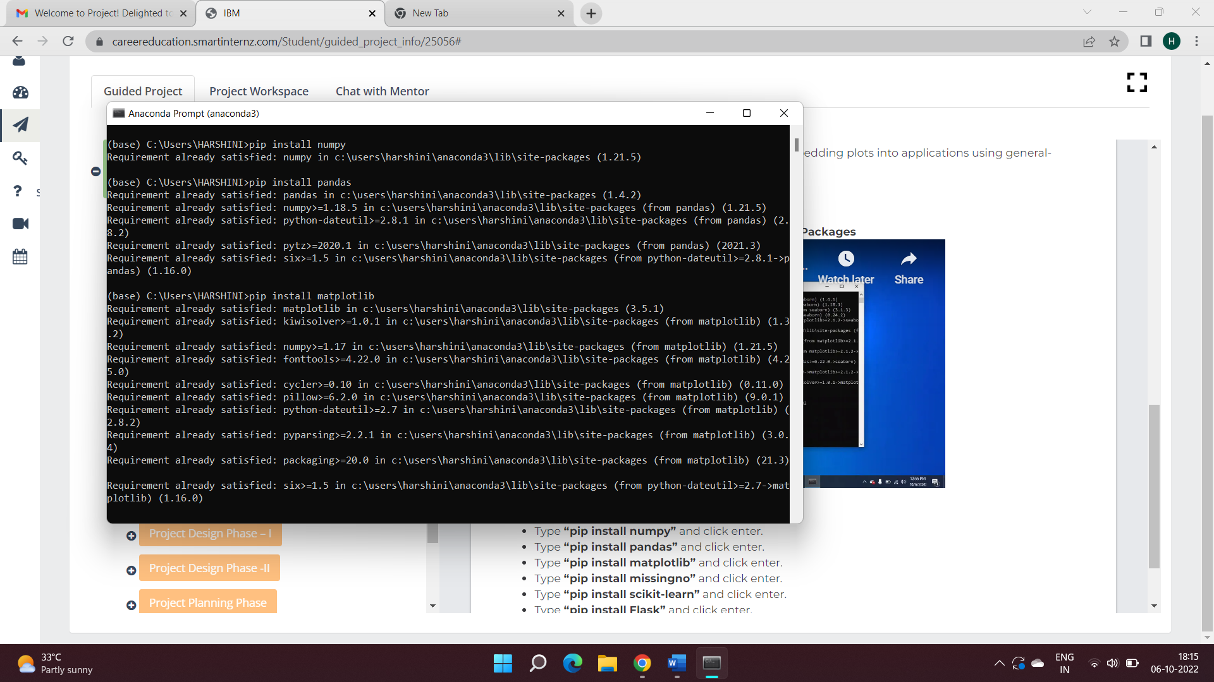

missingno

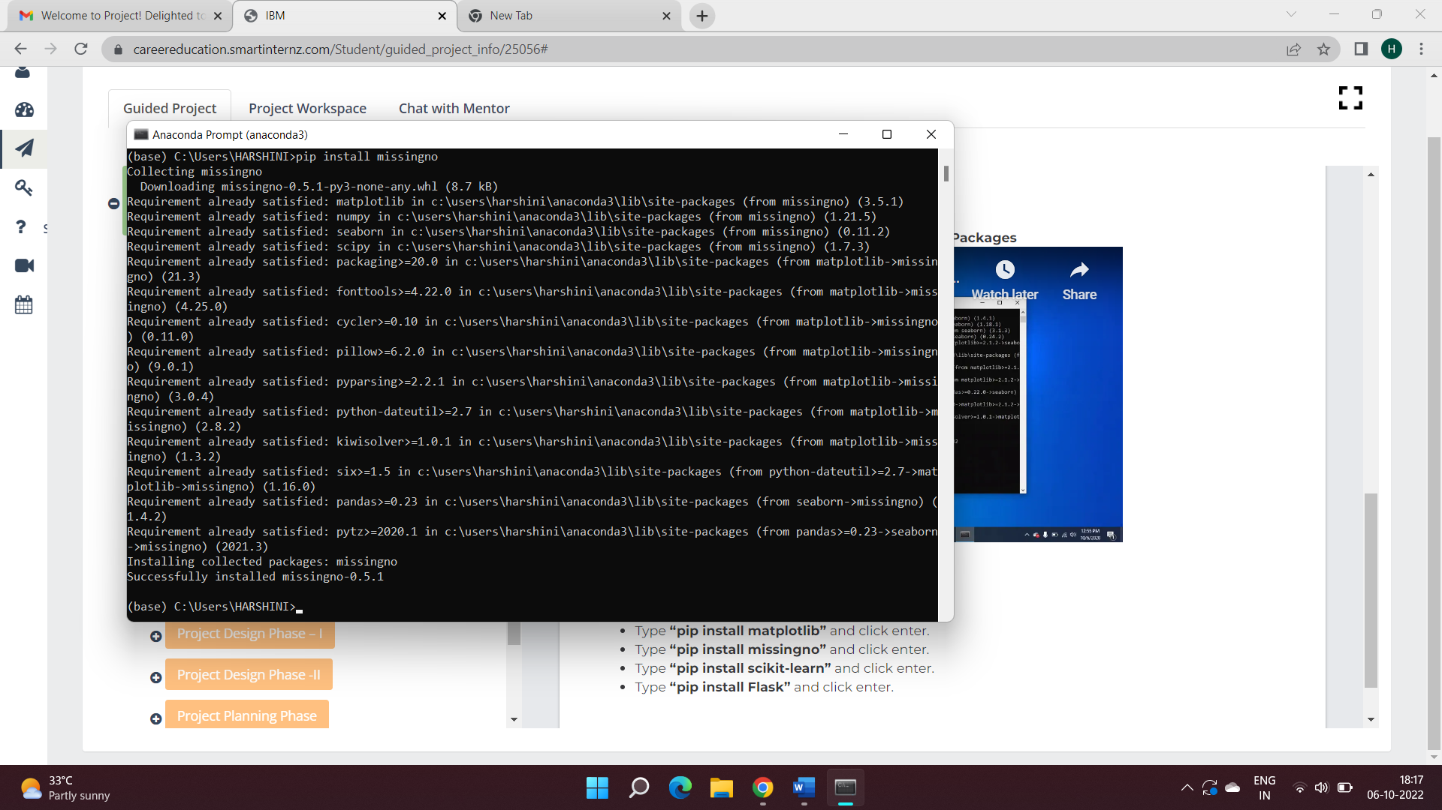

Scikit-learn and Flask

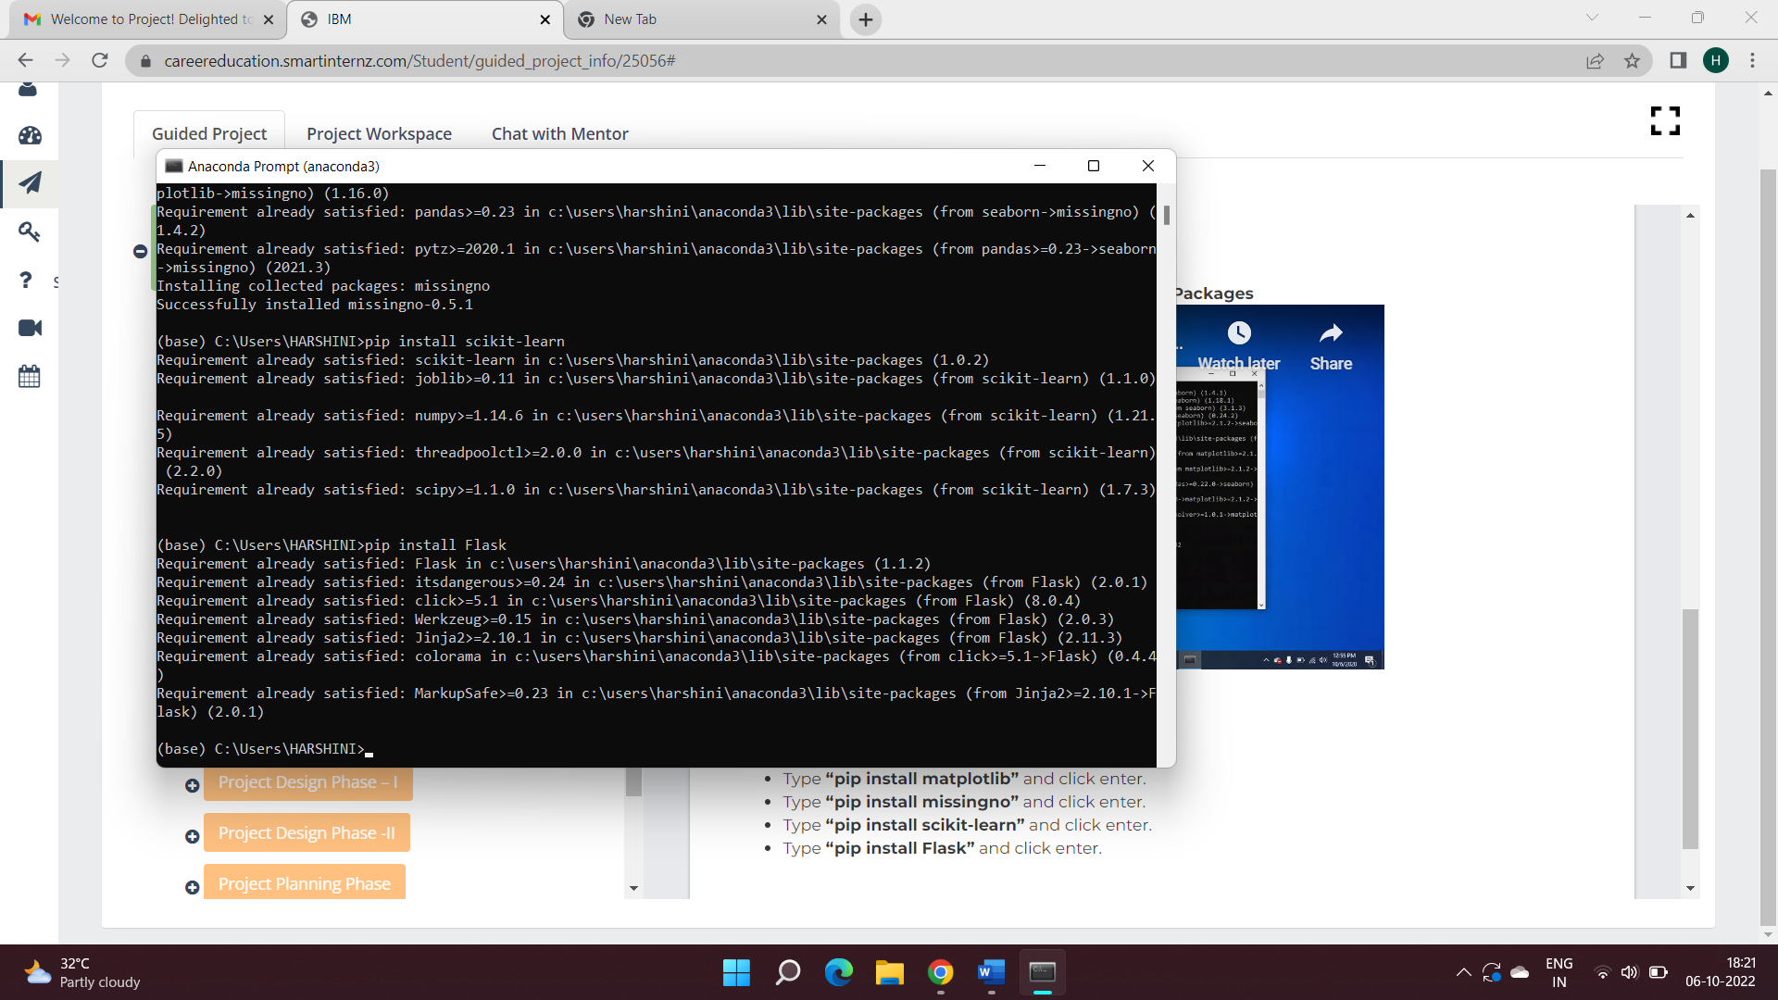

Thus, all the prerequisites are installed on the desktop.